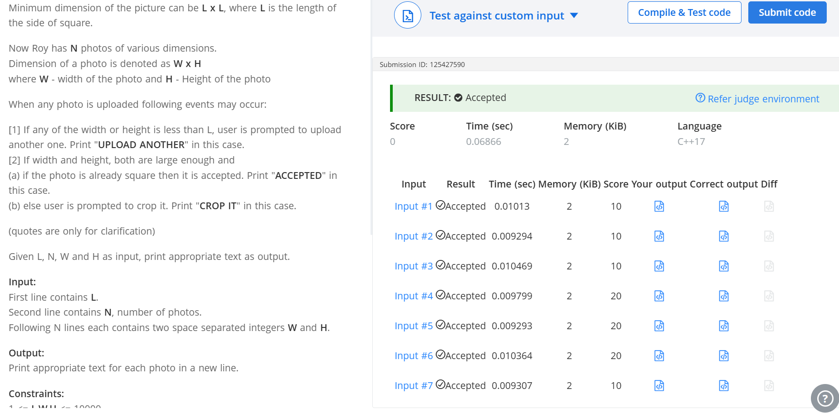
Q Roy Profile photo
#include <iostream>
using namespace std;
int main() {
int L,N,W,H;
cin>>L>>N;
for(int i=0;i<N;i++){
cin>>W;
cin>>H;
if(W<L||H<L){
cout<<"UPLOAD ANOTHER\n";
}
else if(W==H){
cout<<"ACCEPTED\n";
}
else{cout<<"CROP IT\n";
}
}
return 0;
}

